**Python and Bio-Python**

Practical no: 7

Practical Solving:

Perform the following questions using functions:

1.     Open a file and print the contents of the file on the screen

Algorithm:-

Step 1:- Open a file using the open() function where you enter the file location in the brackets.

Step 2:-use the .read() function to read the contents of the file and to print them in the console.

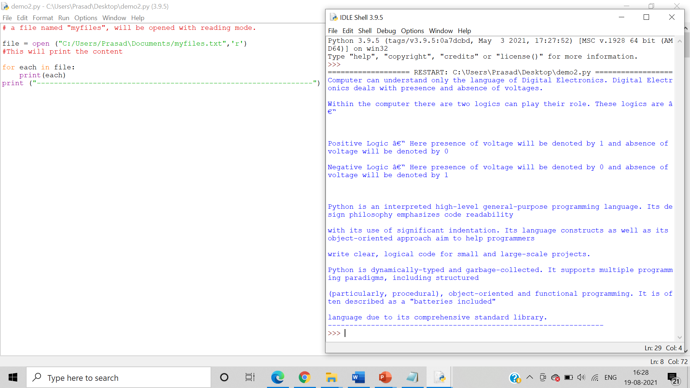

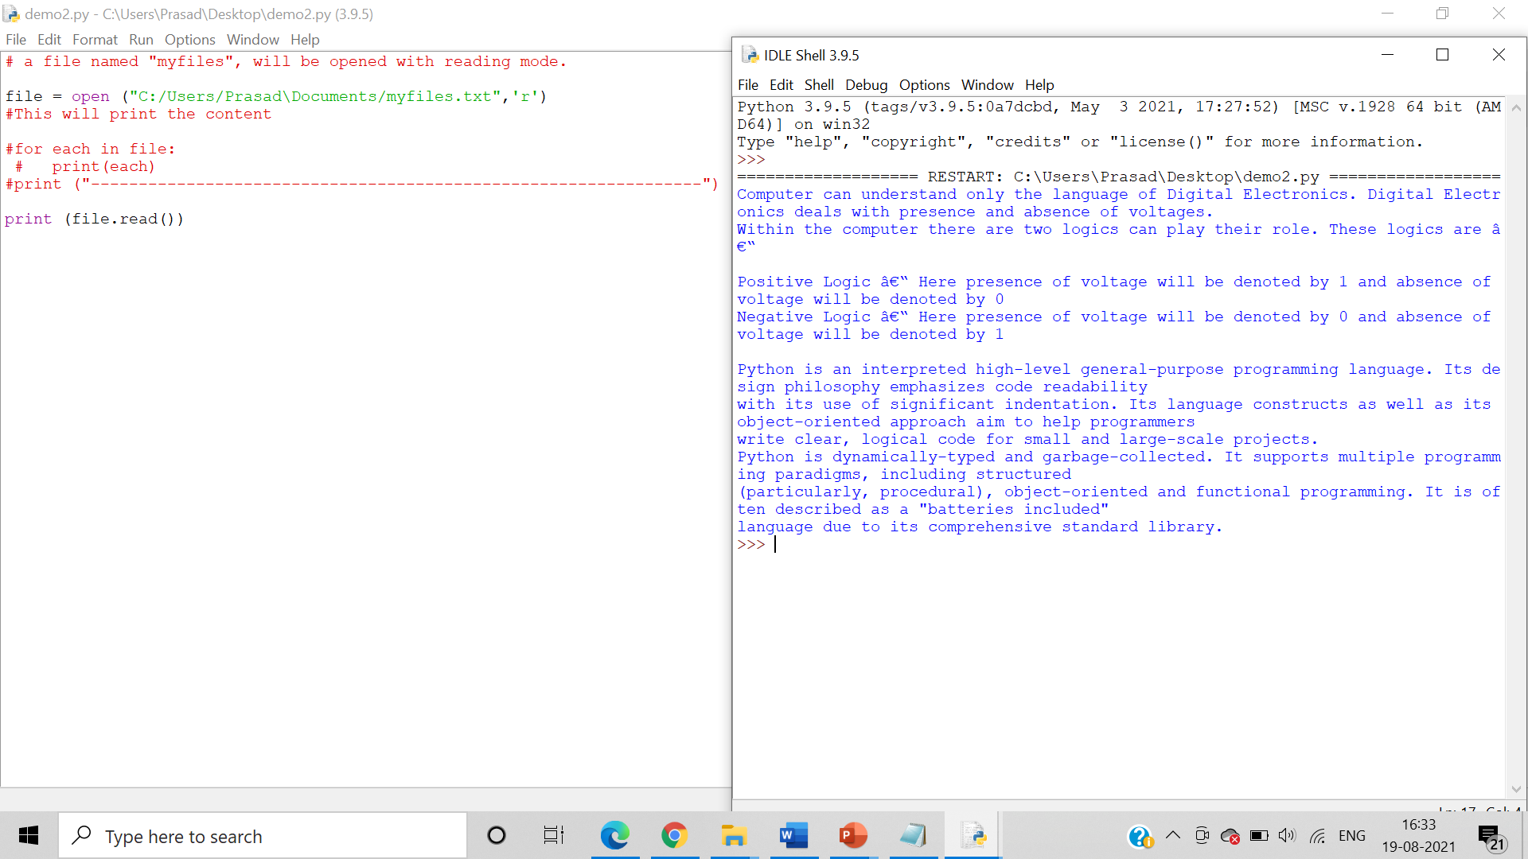

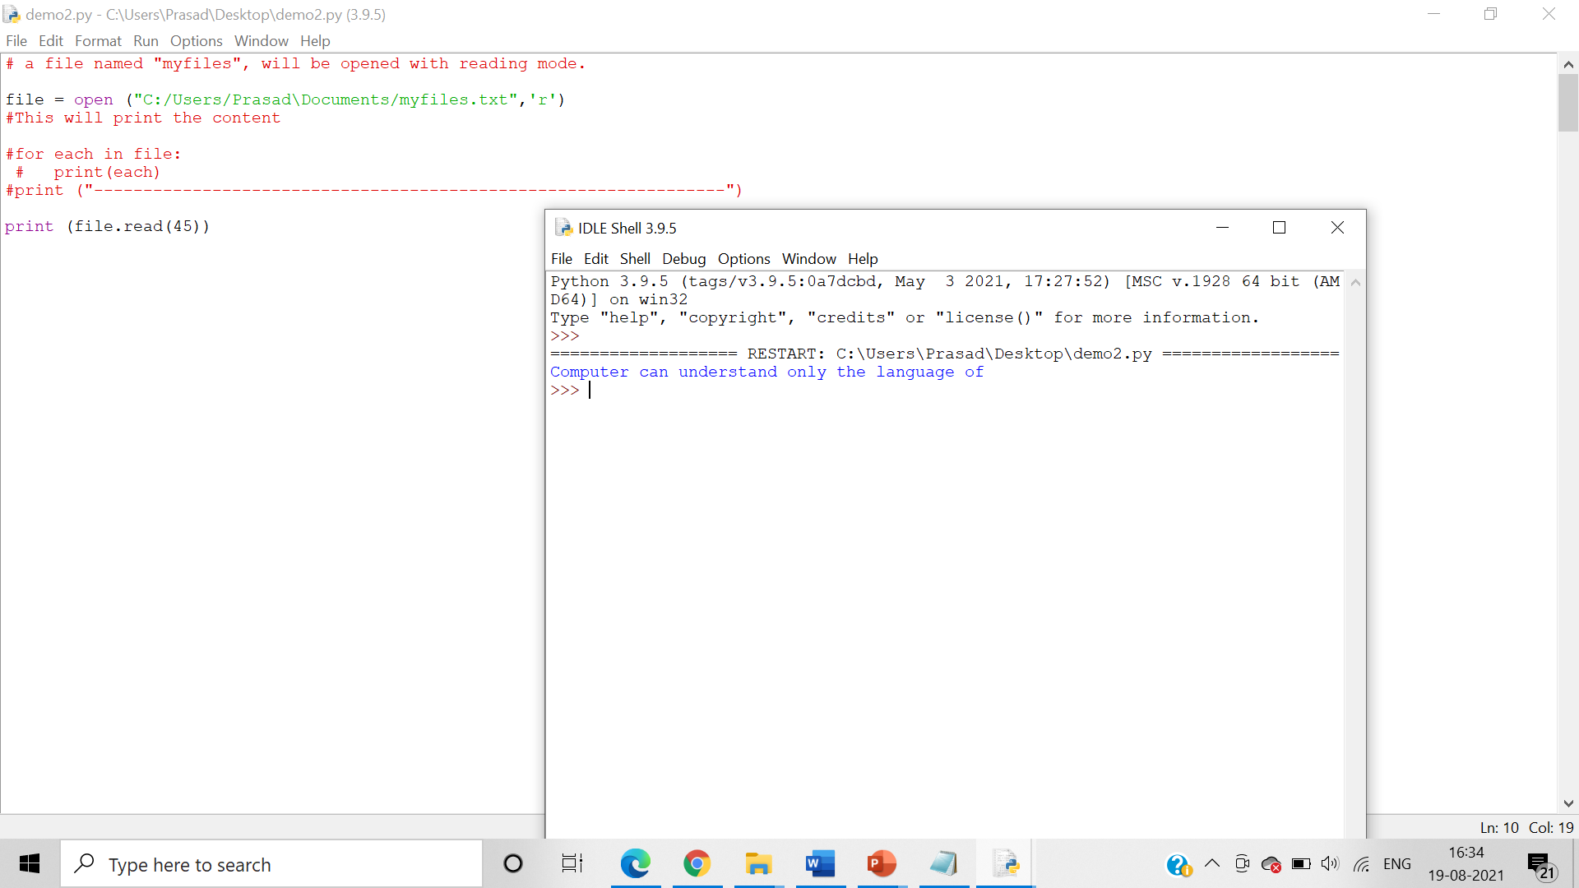

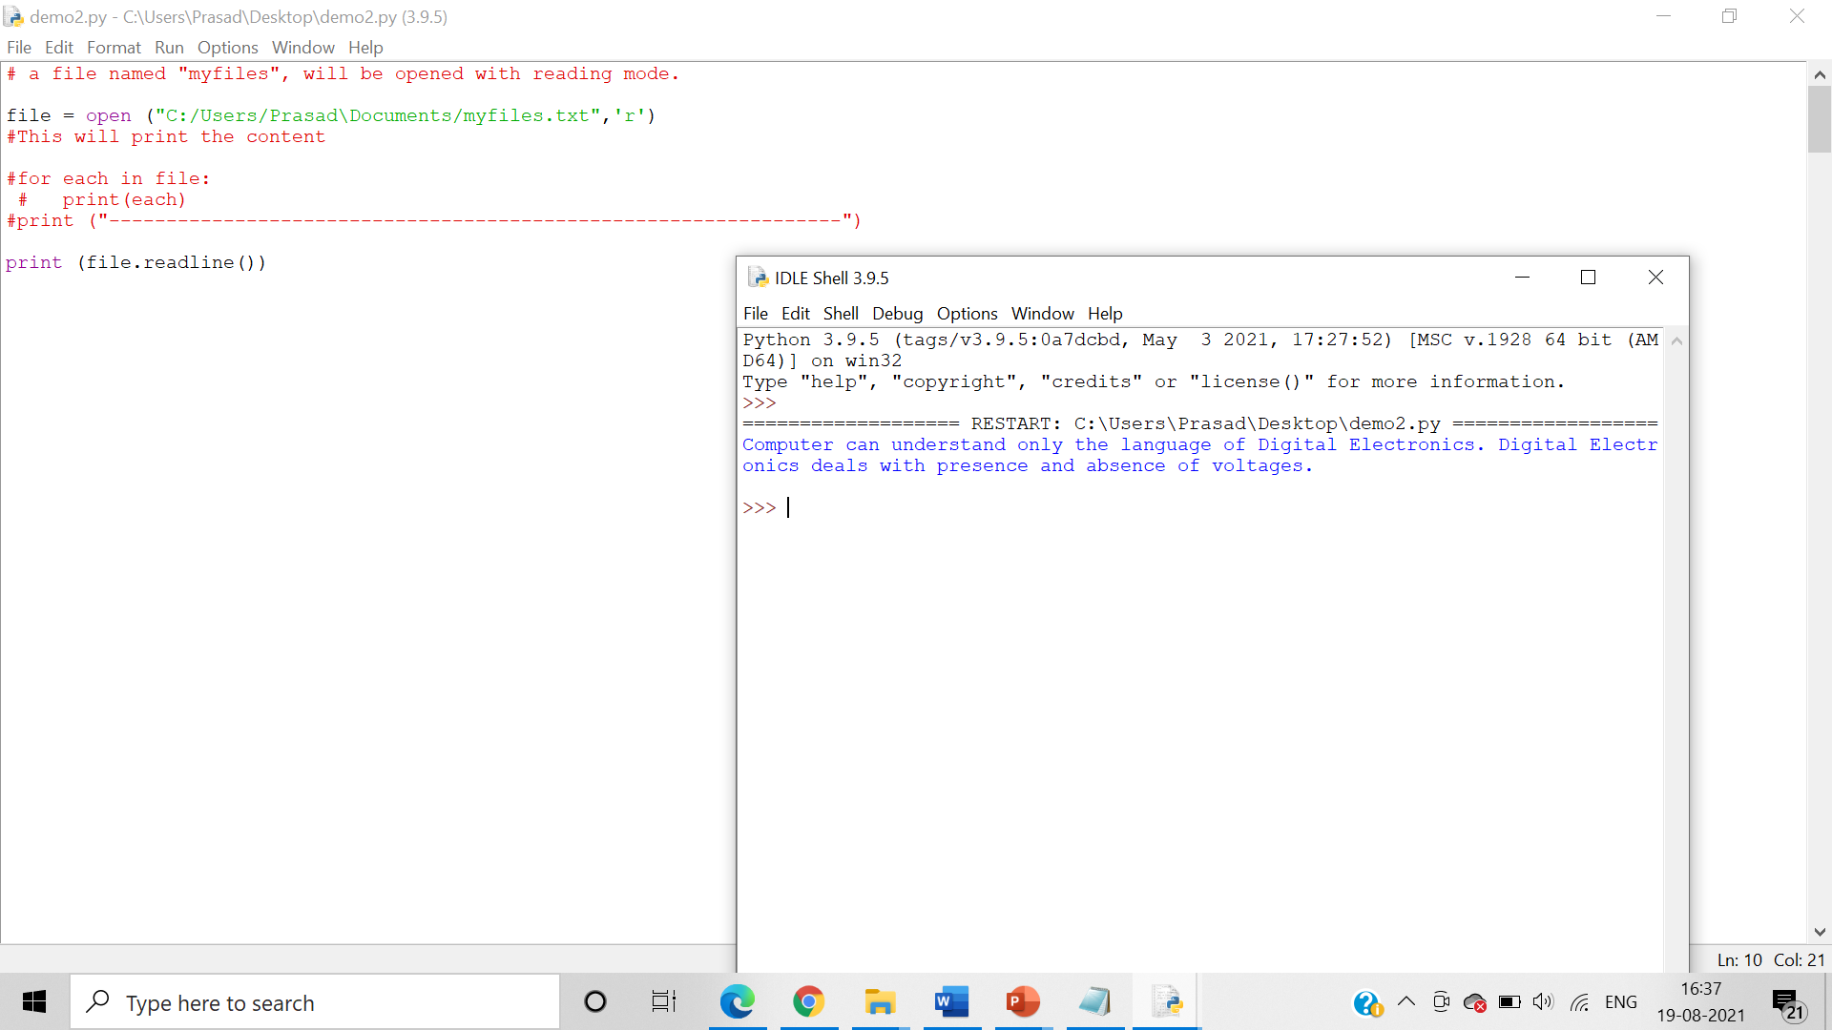

2.     Write a Python program to append text to a file and display the text

Algorithm:-

Step 1:- Open a file using the open() function where you enter the file location in the brackets. Use ‘r’ in the brackets to read the file

Step 2:-use the .read() function to read the contents of the file and to print them in the console.

Step 3:- Open the second file using the open() function where you enter the file location in the brackets. Use ‘a’ in the brackets to append text to the file

Step 4:- Use .close() to close the file.

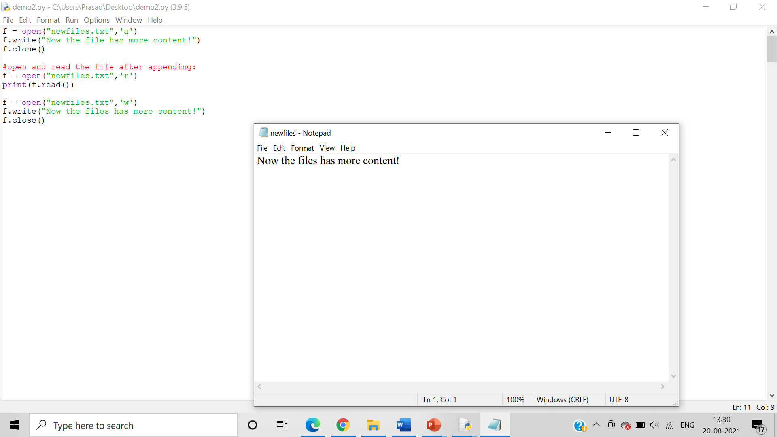

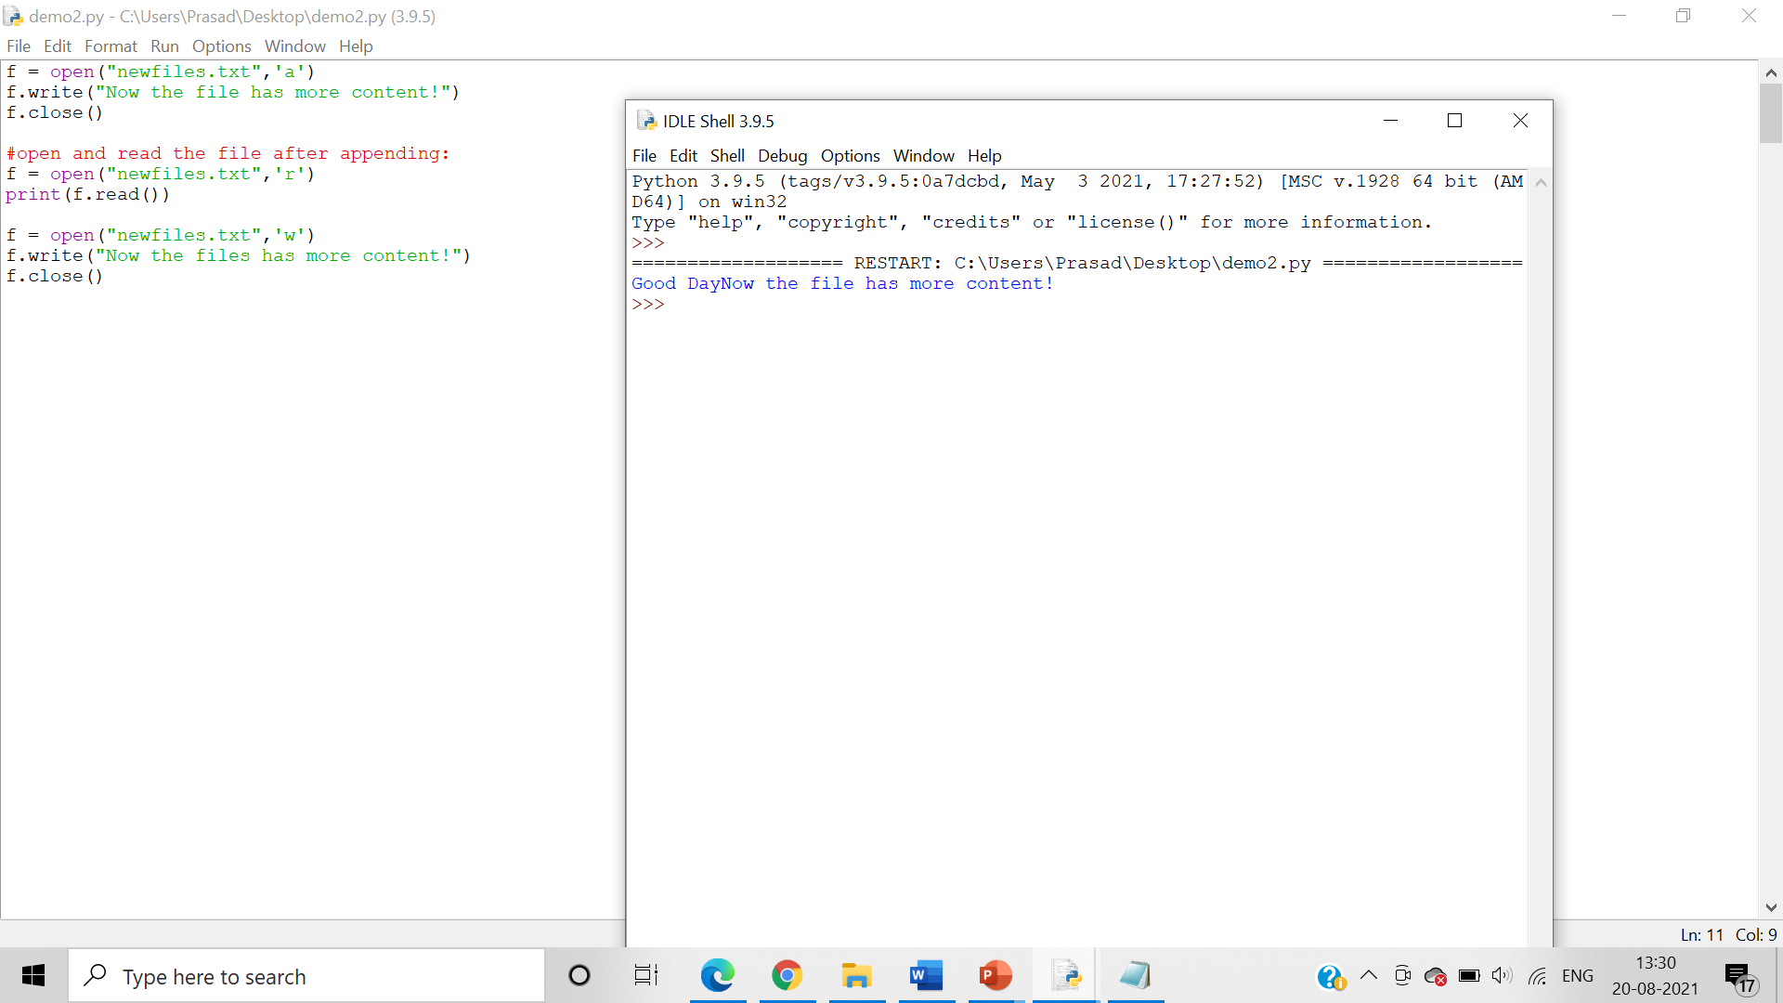

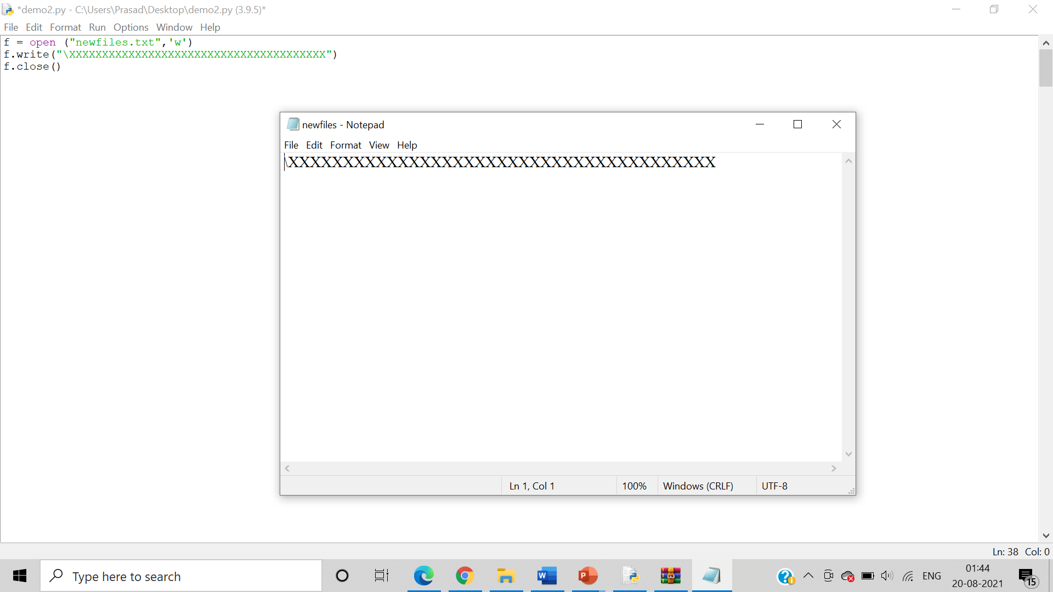

3.     Write a program asking for user details and print those details onto a file

Algorithm:-

Step 1:- Open a file using the open() function where you enter the file location in the brackets. Use ‘x’ in the brackets where x is open for exclusive creation, failing if the file already exists

Step 2:- Use the input() function to take user input.

Step 3:- Then use the with open method to open the text file as output use the .write() function to add the user input to the text file.

Step 4:- Use the .read() function to read the file.

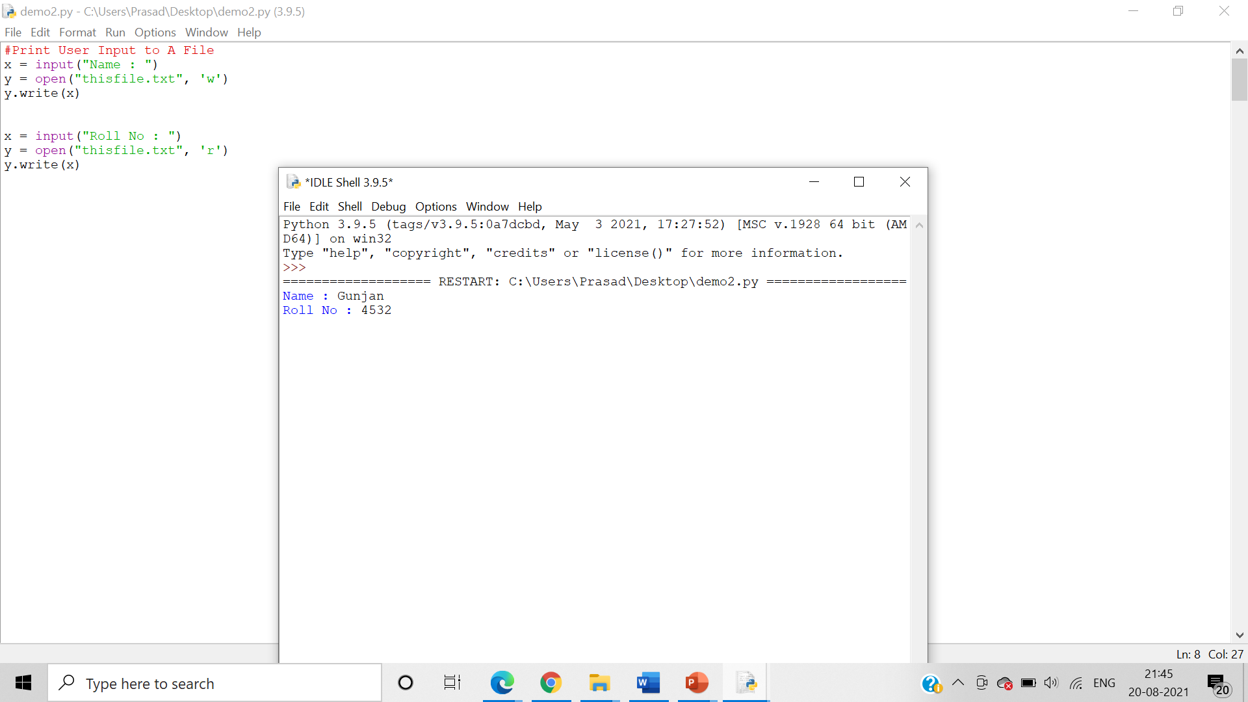

4.     Write a program to copy contents of one file to another

Algorithm:-

Step 1:- Open a file using the open() function where you enter the file location in the brackets. Use ‘r+’ to open a disk file for updating

Step 2:-

Step 3:- Then use the with open method to open the text file as output use the .write() function to add the user input to the text file.

Step 4:- Use the .read() function to read the file.

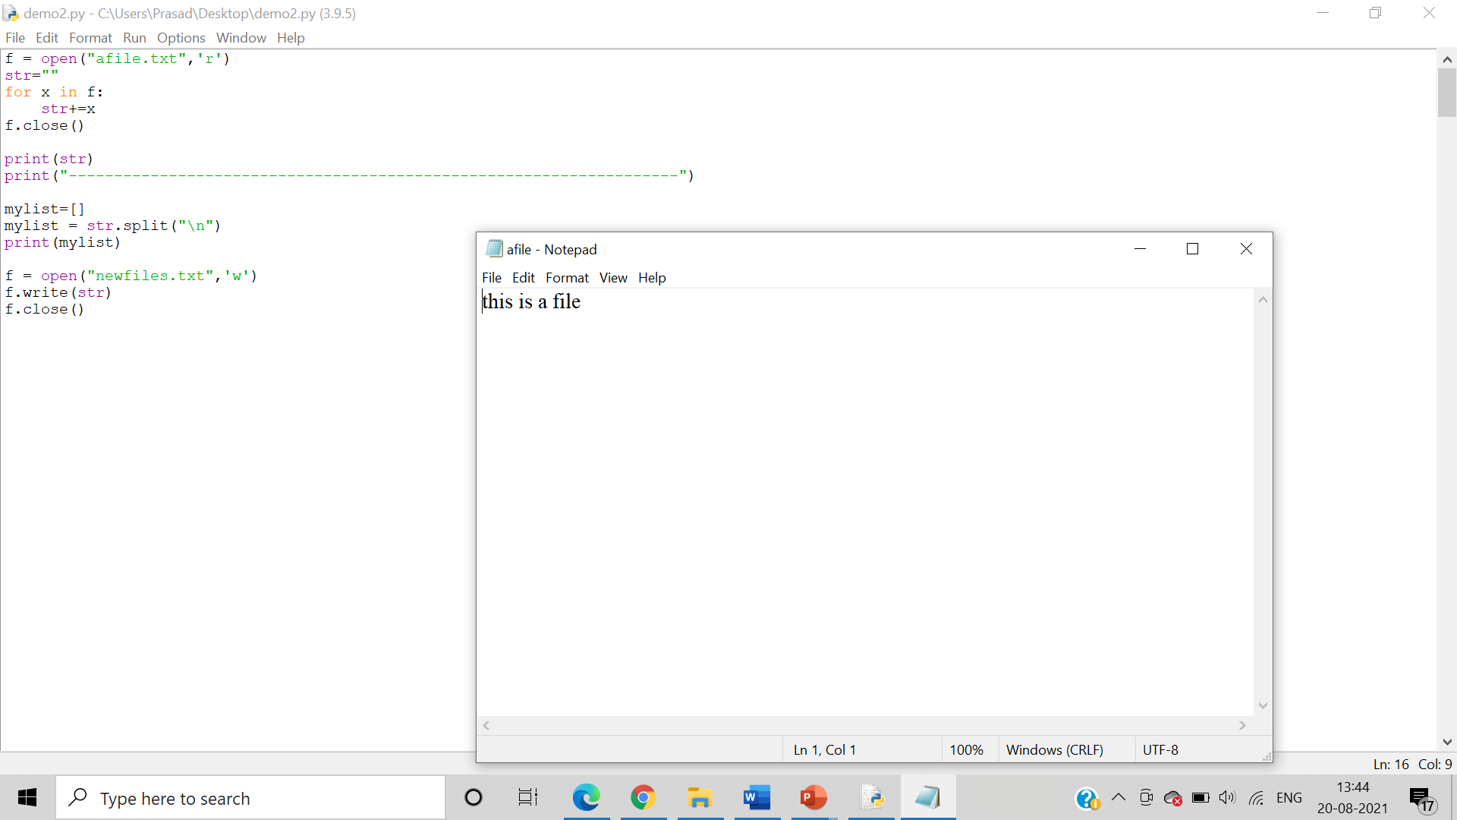

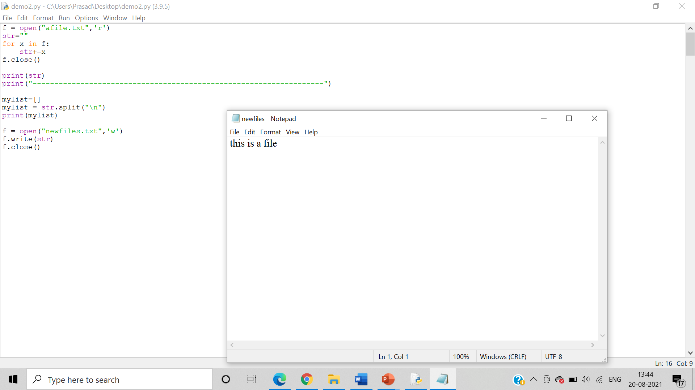

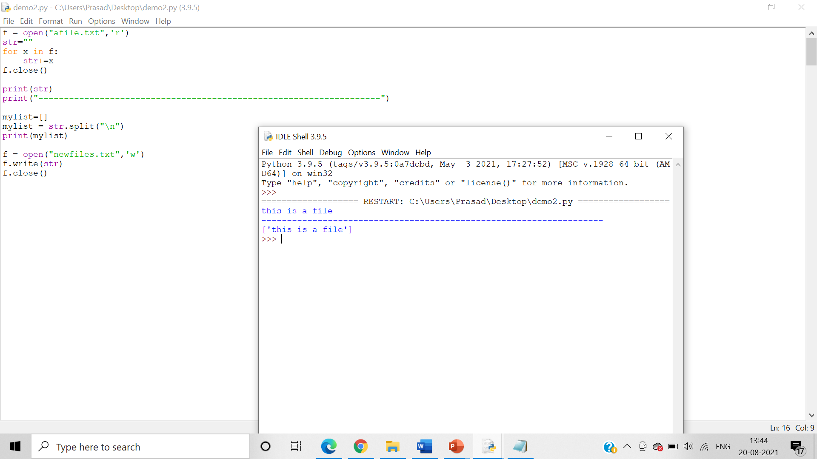

5.     Write a program to reverse the content of a file and store it in another file (apply full reversing : “hello world” => “dlrow olleh” and words reversing : “hello world” – “world hello”)

Algorithm:-

Step 1: Start.

Step 2: Open the files.

Step 3: Access the elements of the file in reverse and write them in thefile.

Step 4: Open the file in read mode.

Step 5: Close the file.

Step 6: So far we have reversed the entire string.

Step 7: To reverse only the alphabets in the strings, we will have to split the string.

Step 8: reverse() returns an iterator that accesses the given sequence in the reverse order.

Step 9: Write this in the file.

Step 10: Open the file in read mode.

Step 11: Close the file.

Step 12: Stop.

